**ABSTRACT**

A medical prescription is a handwritten document that contains directions and a list of medications for people with time sickness, injuries, and other disabilities. Medical prescriptions are written by doctors. The unreadability of the doctor's handwriting on medical prescriptions, as well as the usage of Latin abbreviations and medical terminology, is a common concern for the general public when getting a fresh prescription from a doctor. Even the pharmacists who are responsible for dispensing the medications that are recommended to the patients face difficulties trying to comprehend the illegibly written clinical notes. The drugs are misconstrued as a result, many complications could happen. This outdated procedure for keeping track of prescriptions is inconvenient.A possible way to resolve this problem would be a web based system that can generate electronic medical records based on the inputs in the form of voice and text. The Named Entity Recognition model is employed and pre-processing tasks like tokenization and word limits for the extractions of entities from text such as Drug, Dosage, Symptoms, Strength, Form, Frequency, Duration, Route, or other where each of the words in the text is classified into one of these entities. A recommendation system can also be inculcated that can suggest alternatives to certain medications if the ones prescribed are expensive using a smart ML model.

**1. Introduction**

**1.1 Project Description**

Medical OCR is a web based application that can generate electronic medical records based on the inputs in the form of voice and text. It overcomes the traditional method of storing the medical records manually. Using this web based application one can generate electronic medical records. Now, OCR integrated with AI technology has helped to overcome these limitations. AI-enabled OCR can recognize a greater range of document types and thus achieve significantly higher accuracy rates than many existing softwares, making it the optimal choice for any organization where accuracy and efficiency are important. Beyond this, manual handling and copying are very time-consuming processes, taking up valuable working hours. AI OCR for healthcare can cut down or even eliminate manual entry, saving organizations money and freeing up resources to be better spent in other ways.

**1.2 Existing System**

The existing system consists of manually handling the medical prescription written by doctors. The unreadability of doctor’s handwriting on medical prescription is a prevalent problem. Even the pharmacists who must administer the dispensation of medicines prescribed for patients face problems while reading the clinical notes that are written illegibly. The drugs are misconstrued as a result, which leads to numerous errors. Also, this traditional method of recording and maintaining prescriptions causes inconvenience to patients as well as doctors. Writing prescriptions by hand also takes time which leads to doctors attending fewer patients in the scheduled time.

**1.2.1** **Hung-Kai Chen[4]** et. al proposed an AI based medical prescription recommendation system. This tool was developed for digital training and decision support in cardiovascular disease patients in clinical practice. This study aims to construct a guided exercise prescription system for sub-healthy groups using exercise community data to train an AI model.

**1.2.2** **Aayush Shah** et. al. proposed an AI based application where the idea revolved around digitalising handwritten forms. Most of the government organizations and similar companies use handwritten forms to collect data which should be handwritten. The system proposed by them used different Machine Learning algorithms to extract text data and automatically convert it into text that could be understood by the computer or machines. There are various techniques used for character recognition from images of handwritten or printed text as input. Neural Networks such as Convolutional Neural Networks have been applied to implement character recognition of handwritten text.

**1.3 Objectives**

The proposed system will help automate the process. This application can cut down or even eliminate manual entry, saving organizations money and freeing up resources to be better spent in other ways. With this system, accuracy is ensured and all actions are logged into the database for analysis and accountability. This allows them to ensure efficiency and confidentiality of the patient’s reports in future handling. AI-enabled OCR can help protect sensitive data by facilitating the digitization of data, which helps organizations to move away from unsecured, easily lost physical documents. Digital documents can also be selectively edited to redact sensitive information, without the need to manually copy or edit them.

A recommendation system can also be inculcated that can suggest alternatives to certain medications if the ones prescribed are expensive using a smart ML model.

**1.4 Purpose, Scope and Applicability**

**1.4.1 Purpose**

The main purpose of this system is to reduce the usage of paper and help the patient and pharmacist with the ease of reading prescriptions also making this work process entirely digitized.

**1.4.2 Scope**

It will give good readability to pharmacists as well as people with no medical background in cases of emergency. The efficiency of the doctor is improved as there is a shift of burden regarding the unreadability. The system would also recommend alternative medicines in case of unavailability of a particular medicine. This will reduce the manual work and all the medical history and prescription will be saved in digitized format.

**2. System Analysis and Requirements**

**2.1 Problem Definition**

The unreadability of the doctor's handwriting on medical prescriptions, as well as the usage of Latin abbreviations and medical terminology, is a common concern for the general public when getting a fresh prescription from a doctor. Even the pharmacists face the same issue while reading the prescriptions.

**2.2 Requirement Specification**

**2.2.1 Functional Requirements**

* Doctor should be able to register/login to the system
* System should be able to collect and store data entered by doctor
* System should be able to perform authentication of doctors
* Successful authentication allows doctor to record voice
* System should be able to convert voice to text using Speech Recognition API
* System should be able to send text to Named Entity Recognition Model
* Preprocessing task like Tokenization , filtering , etc are done
* System should be able to extract needful information like drug name, dosage, symptoms, duration, etc is done
* The model output is then sent back to the application in JSON format.
* A medical prescription is generated using the model output.
* The prescription is re-verified by the doctor and sent to the patient via email.

**2.3 Block Diagram**

**2.3.1 Solution Architecture**

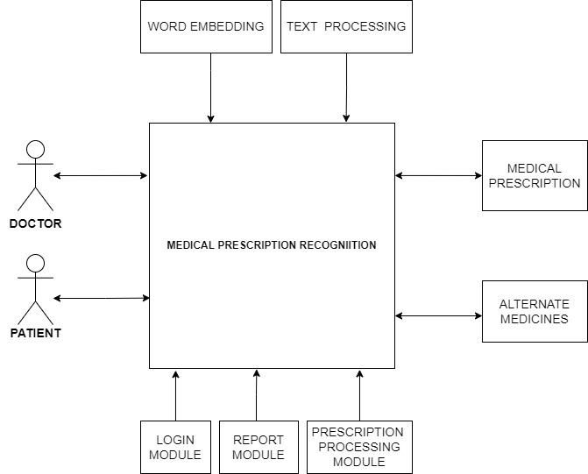

**2.4 Specialization Concepts:**

1. **Image processing:**

Text extraction is done using a Python based OCR tool from the uploaded image. The text from document images is detected and Natural Language Processing algorithms deciphers the text and make sense of what the document conveys.

1. **Speech Recognition:**

Speech recognition APIs are used to recognize voice input from the doctor to extract meaningful information. Speech recognition systems use computer algorithms to process and interpret spoken words and convert them into text.

1. **Named Entity Recognition :**

This NLP task is done on the extracted text from the NLP libraries to establish a relationship between them. It involves the identification of key information in the text and classification into a set of predefined categories.

1. **Collaborative Filtering**

Collaborative filtering is probably the most widely used algorithm for creating product recommender systems in online retailing. This algorithm is comparatively simple to implement and generates relevant and accurate recommendations.

**2.5 System Requirements**

**2.5.1 Software and Hardware Environments**

**Hardware Requirements :**

* **Processor:** Intel Core i5 8th Gen
* **RAM:** 16 GB
* **Hard Disk:** 1 TB

**Software Requirements:**

* Operating System - Certified Distribution of WINDOWS
* Visual Studio
* Web Browser - Google Chrome
* Database(Backend) - SQL
* Python 3.6
* NLTK
* Pytorch
* Scispacy

**2.6 Module Description:**

**2.6.1** **Authorization And Authentication Module:**

During registration, the system should take doctor's Personal information and stores it into the database which is stored in plain text format except passwords are stored as hash instead of the original input for security purposes.The System should authenticate the user (doctor or patient) .At the time of login, it takes the email id and password from the doctor and checks whether it is valid or not by doing authentication. Doctors will not be able to generate the prescription without authentication.

**2.6.2 Prescription Processing Module:**

The system should provide doctors the ability to generate prescriptions by allowing inputs in either voice-based commands or by uploading the document. Converted text will then be sent to a Named Entity Recognition model which will extract entities from text such as Drug, Dosage, Symptoms, Strength, Form, Frequency, Duration, Route, or other.

**2.7 Conceptual Models**

**2.7.1 Data Flow Diagram**

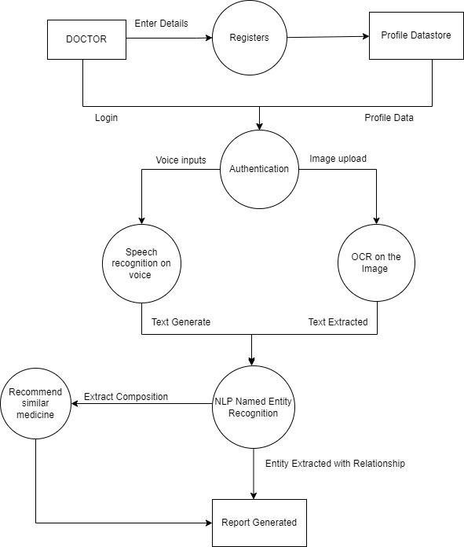

**2.7.2 ER Diagram**

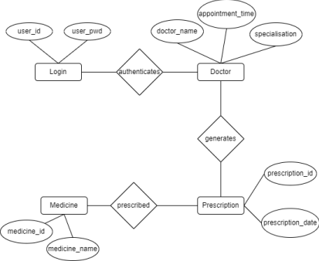

**3. System Design**

**3.1 System Architecture**

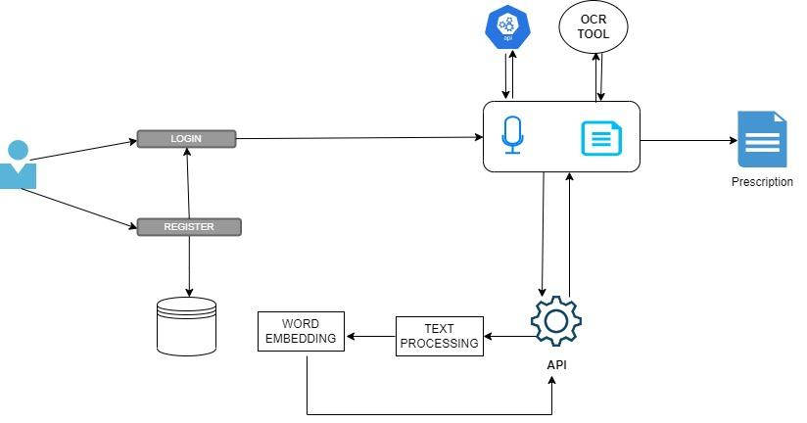

**3.5 Interface Design and Procedural Design**

**3.5.1 User Interface Design**

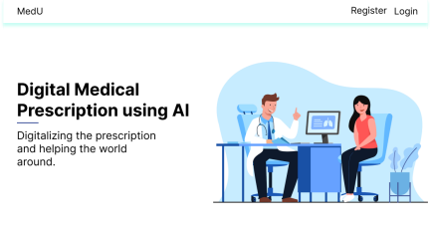

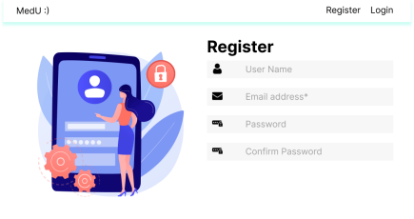

**3.5.2 Application Flow/Class Diagram**

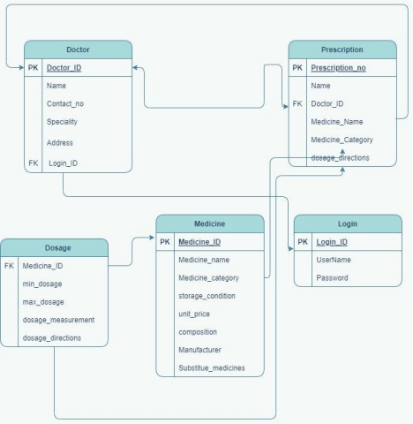

**4. Implementation**

4.1. Implementation Approaches

4.2. Coding Standard

4.3. Coding Details

4.4. Screen Shots

5. Testing

5.1. Test Cases

5.2. Testing Approaches

5.3. Test Reports

**Module 1:**

**Authentication :**

| **Test Case ID** | **Test Case Name** | **Test Case Description** | **Req** | **Execution Steps** | **Expected**  **Output** | **Result** |
| --- | --- | --- | --- | --- | --- | --- |
| 1.1 | To check login functionality for valid input | Check response when valid user-id and password is entered. | 1 | 1.1.1). Go to login page  1.1.2) Enter user-id  and password  1.13) Check the MEDU database for an account with specified details in the Doctor table .  1.1.4)  Go to dashboard page if details are valid | 1. Login should be successful  2) Path should be existing  and pages for Doctor Dashboard should be present. | Pass |
| 1.2 | check login  functionality  for invalid  input | Check response  when invalid  user-id or  password is entered | 1 | 1.2.1) Check database  for account with  specified details in  Doctor table.  1.2.2) Redirect to login  page to retrieve the  details | 1.Entered  data is invalid,  No account  with the  specified user-  id and  password  exits. Ask for repopulating details | Fail |

**Module 2:**

**References**

1. Handwritten Optical Character Recognition (OCR): A Comprehensive Systematic Literature Review (SLR) by Jamshed Memon et. al.
2. An Overview of the Tesseract OCR Engine

https://ieeexplore.ieee.org/abstract/document/4376991

1. Digitization of Data from Invoice using OCR by Venkata Naga Sai Rakesh Kamisetty et. al. , 2022, 6th International Conference on Computing Methodologies and Communication (ICCMC)
2. An AI-Based Exercise Prescription Recommendation System by Hung-Kai Chen et. al, 2021